

**NORTH SOUTH UNIVERSITY**

Department of Electrical & Computer Engineering

**LAB REPORT**

Course Name: Computer Organization & Architecture

Course Code: CSE332L

Experiment Number: 06

|  |
| --- |
| Experiment Name:  Design of a 4-bit ALU. |

Submitted By

Name: MD. ABU AMMAR

Id: 1821944642

Section: 05

Submitted To

Instructor: Md. Saidur Rahman

|  |  |
| --- | --- |
| Experiment Date: 19-12-2020 | Submission Date: 19-12-2020 |

**Experiment Name:**

Design of an ALU.

**Objectives:**

* We have to build a 1-bit ALU with specific set of instructions.
* We have to implement incorporate equality check (zero signal), overflow detection and other necessary flags.
* We have to build 4-bit ALU by connecting 4 1-bit ALU.

**Circuit Diagram:**

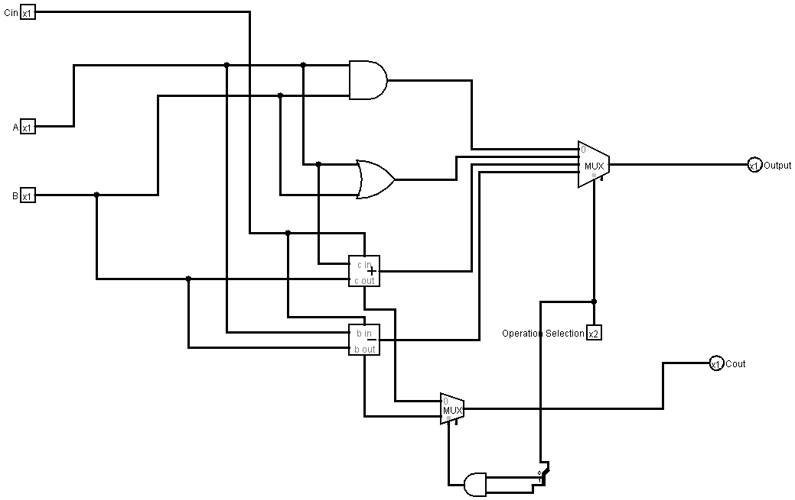

**Figure:** Circuit diagram of 1-bit ALU.

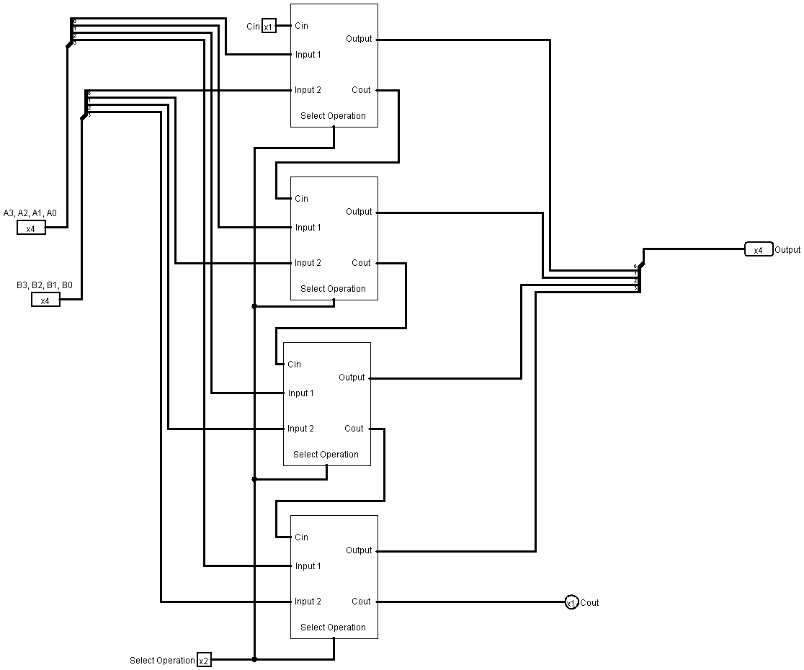

**Figure:** Circuit diagram of 4-bit ALU by the sub circuit of 1-bit ALU.

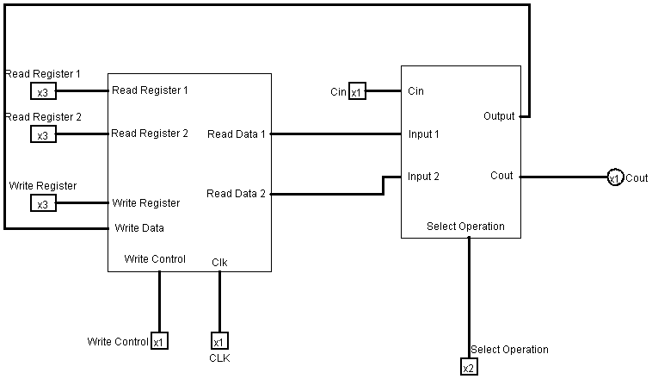

**Figure:** 4 operations performed by4-bit Register File and 4-bit ALU

Function Table:

|  |  |  |
| --- | --- | --- |
| S1 | S2 | Operation |
| 0 | 0 | AND |
| 0 | 1 | OR |
| 1 | 0 | ADD |
| 1 | 1 | SUB |

**Discussion:**

After completing the lab, we got a clear idea to build 1-bit ALU and 4-bit ALU. We have 4 operations to implement in the ALU initially for 1-bit where we have two 1-bit input (A, B). To control which operation to be performed we take a 4*1 MUX with Selection bit 2, the combination of Selection bit will choose the particular operation as mentioned above in Function table. From the ADDER and SUBTRACTOR we got two Cout but we can only have one Cout output in the ALU so we use 2*1 MUX with Selection bit 1 to take only one Cout at a time where we take the Selection bit input from an AND gate which is connected with our Operation’s MUX ‘s selectin pin so that we don’t need extra input, and at the end we get our desired output from the MUX. So, in total we have 4 inputs and 2 outputs.

By the sub circuit of 1-bit ALU we have built a 4-bit ALU where Cout of previous ALU is connected with its next ALU’s Cin and from the last 1-bit ALU we got our Cout and of course all the Selection Pins are shorted, at last we got our 4-bit output from four 1-bit ALU.

Then in the final circuit we include our previous lab’s 4-bit Register File to take 4-bit input for 4-bit ALU and store 4-bit output from the 4-bit ALU.

As the full lab 6task, we did in Logisim software so we did not get any error.